

Workday – Learning Lab Guide (Employee)

Contents

Learning Lab Purpose 3

Guide Disclaimer 3

Instructions 3

What Is Workday? 3

Workday Fundamentals 4

Getting to Know Workday 5

Activity 1: Navigating Workday 5

Employee Self Service Activities (Faculty, Staff and Student Workers) 10

Activity 1: Update Personal Information 10

Activity 2: Upload My Experience 11

Activity 3: Enter Time 12

Activity 4: Request Time Off 15

Appendix 1: Workday – Terminology 18

Appendix 2: Common Worklets in Workday 21

# Learning Lab Purpose

The purpose of the Learning Lab is to provide Faculty, Staff and Student Workers with the ability to explore the self-service functions and capabilities of the Workday system.

The session is intended to provide insight toward some of the most common Workday transactions performed by Faculty, Staff and Student Workers but is not intended to be comprehensive of everything that may be performed in the system.

# Guide Disclaimer

Due to continuous improvements to the Workday system, the guide may not reflect recent updates to the Workday environment.

# Instructions

Use this guide to explore the employee self-service functions and capabilities of Workday. Complete the Workday actions using the guidance provided in each section.

*NOTE: Any updates or changes made in the Workday Sandbox environment will not be maintained as part of the production Workday system configuration. This Sandbox is only provided for additional user experience.*

# 

# What Is Workday?

* Workday is a cloud-based system that The Texas A&M University System uses to manage the Human Resources, Benefits and Payroll functions for all employees
* Workday *unifies* processes that in the past required multiple systems
* Workday modernizes the way we do business in the A&M system
* Some of the major benefits of Workday include:
  + Streamlined processes and technology, including the ability to sign on to one system to complete processes
  + Organized collection of employee data, performance and talent management that provides you with one single source for obtaining important information
  + Shared, real-time data and dashboard reporting replacing static reports and delayed action for faster business decision making
  + Enhanced / improved career growth and engagement for Employees, Managers, and HR personnel

# Workday Fundamentals

Workday is built on three basic fundamentals:

* **Organizations:** Organizations are used to group people, resources, workers and their institution or agency. They provide management, visibility and reporting structures for resource allocation
* **Business Process:** A business process is a set of tasks used to accomplish a specific goal such as posting a position. Workday will automatically route specific steps in a workflow to those responsible for them. Certain processes may require multiple approvals within Workday and may also have additional approvals outside of Workday
* **Security Roles:** Security roles determine what you can see and do. Initiation of a business process is determined by the employee’s security role in the Workday system. The same business process may be initiated by multiple security roles
  + Security roles are not job titles. The roles provide Workday users access to appropriate data within the assigned organization structure. The roles also determine functional responsibilities, routing of actions in a business process and access to reports
  + Workday users will be assigned a security role based on the access they will need in the system. Some users may be assigned to multiple security roles depending on their duties and responsibilities

# Getting to Know Workday

## Activity 1: Navigating Workday

This section provides details around basic navigation in Workday. Follow the instructions to explore system navigation features.

#### Accessing Workday

All A&M System employees will access Workday through Single Sign On (SSO).

Click the Workday shortcut on the desktop / browser or type the URL, <https://impl.workday.com/tamus6/d/home.htmld> into the browser address bar. If you are not already logged into SSO, you will be prompted to authenticate into Workday using either your SSO or system member’s credentials. You can review the list of System members at the SSO login page.

#### Workday Home Page

The Workday Home page provides an icon-rich user experience much like what exists on your smart phone or tablet. These icons, called worklets, enable you to quickly access tasks that you will perform on a daily basis as well as the links to pages that will provide additional resources for you. For example, you can use the **Personal Information** worklet to access or modify the details about your emergency contacts.

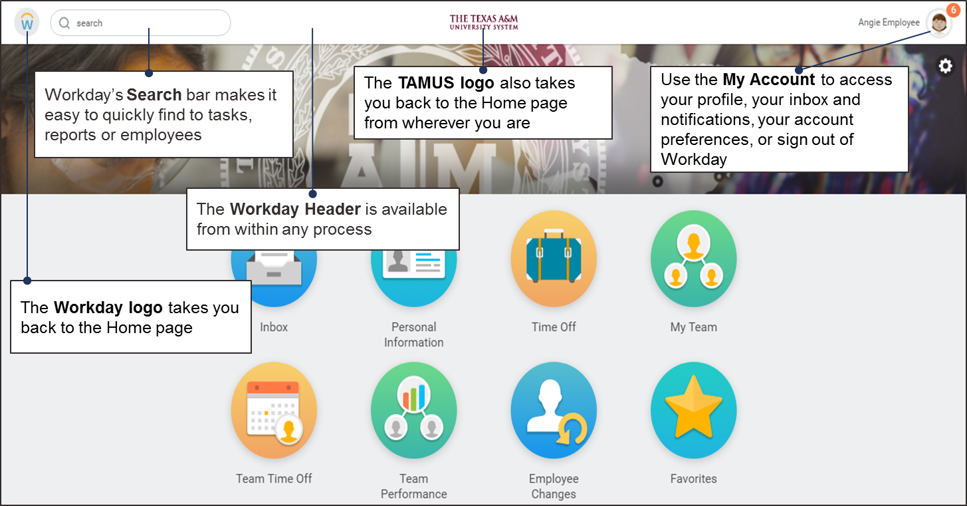

#### My Account

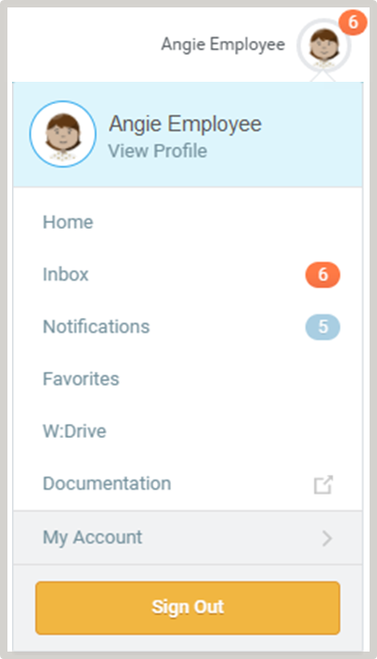**Click the My Account icon.** The **My Account** iconprovides access to thedrop-down menu that gives you options and access to things such as:

* Your Worker Profile
* The Home page
* Your inbox and notifications
* Favorites you have saved
* Account settings
* Access to sign out of Workday

#### Working with Worklets

* A **worklet** is an icon found on the Home page that makes it easier to access information needed on a routine basis
* Some examples of tasks that you can access through worklets include:
  + View paystubs or benefits elections
  + View reports
  + Enter time or request time off
  + Access your Inbox
* Please see the **Appendix** for a list of common worklets in Workday

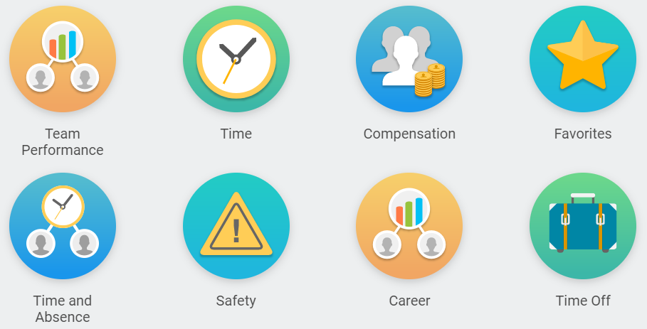

#### Workday Inbox

* Workday is a workflow-based application. All approvals, reviews, to-dos and other action items are accessed through your Workday Inbox
* Action items remain in your Inbox until you (or someone with the same security role) review and take the appropriate action
* Access your Inbox by clicking the **Inbox** worklet on your Home page

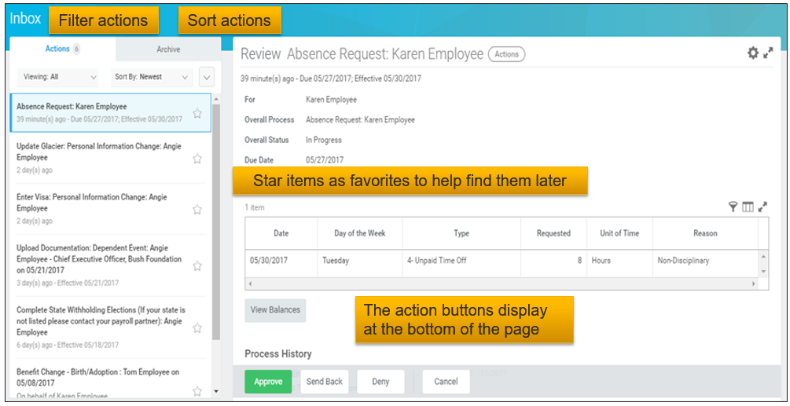

#### Using Notifications

* Notifications are messages from Workday letting you know about tasks that have been completed or may require additional attention
* Examples of notification messages:
  + Your request for time off has been approved
  + The job requisition you created for an administrative assistant has been successfully completed
* **To view Notifications**:
  1. Click the **My Account** icon
  2. Then, select **Notifications** from the menu

NOTE: All Workday Notifications and To Do tasks will trigger an email notification to your email of record.

#### Workday Search Bar

* The Search bar is one of the most powerful tools in Workday for finding information
* Search for people, tasks, reports and more by using the Search bar located in the top-left corner



* The Search bar can predict what you are looking for as you type and will present options in a drop-down menu
  + You can enter partially typed words but no misspelled words
* Similar to common Internet search engines, a keyword or command can be entered and a list of search results will be displayed. The results can be filtered in order to help you narrow your search and find what you are requesting. Workday’s intuitive system will also aid you in finding what you are looking for by displaying common search items as you begin to enter text
* The categories on the left will help you narrow down your search results by filtering out other search results. For example, when you search for “Time Off”, you see the top 30 items. If you want to see Time Off information related to Payroll, click Payroll on the left sidebar. In the second screenshot below, you can see where a list of Time Off items related to Payroll appear

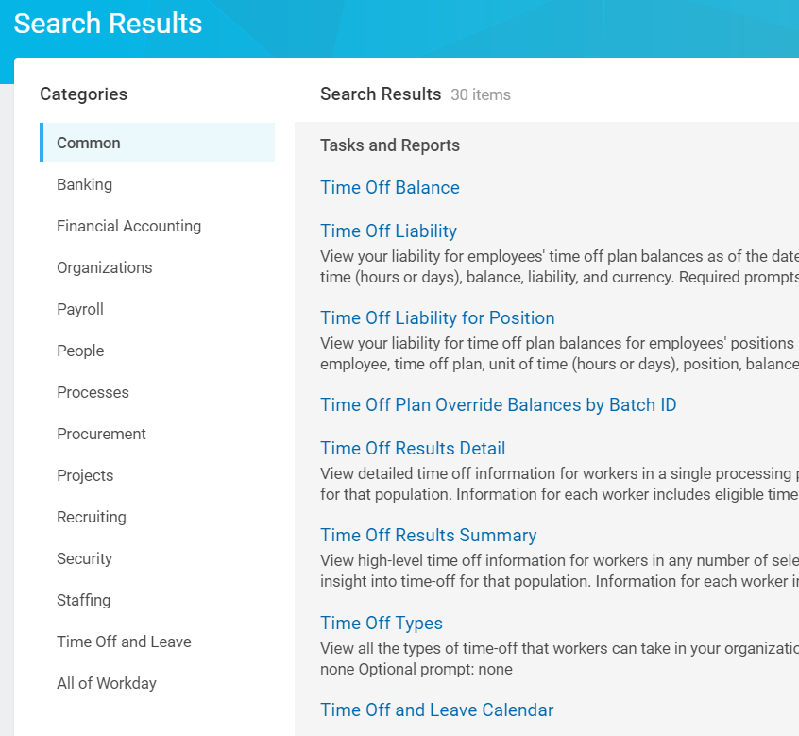 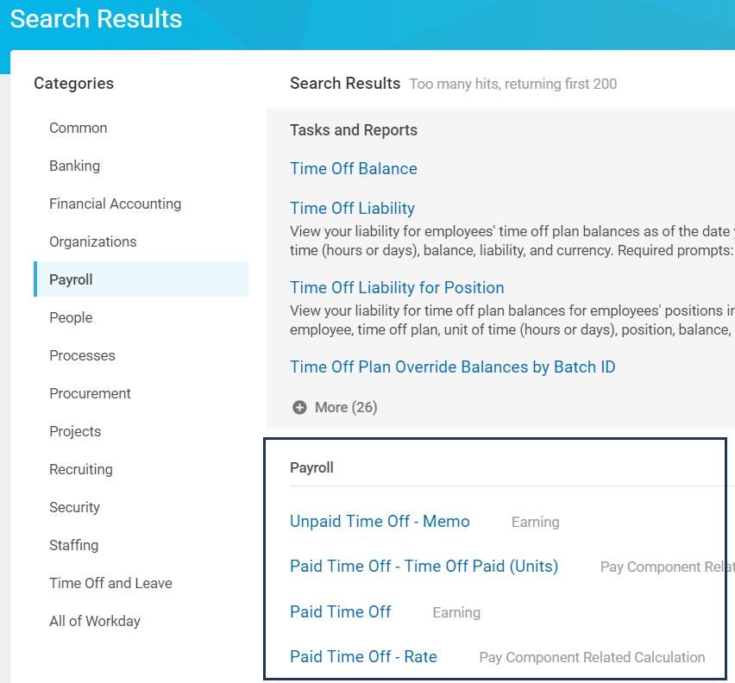

#### Worker Profile

The Worker Profile provides you with basic information about workers in the A&M System who are in Workday. Your security role determines how much information you can see. The Worker Profile displays information such as the organizations employees belong to, who their managers are, and an overview of their education and work experience. Other potential information includes contact, career, personal, performance, feedback, and pay information; once again, the type and level of information displayed depends on your security role.

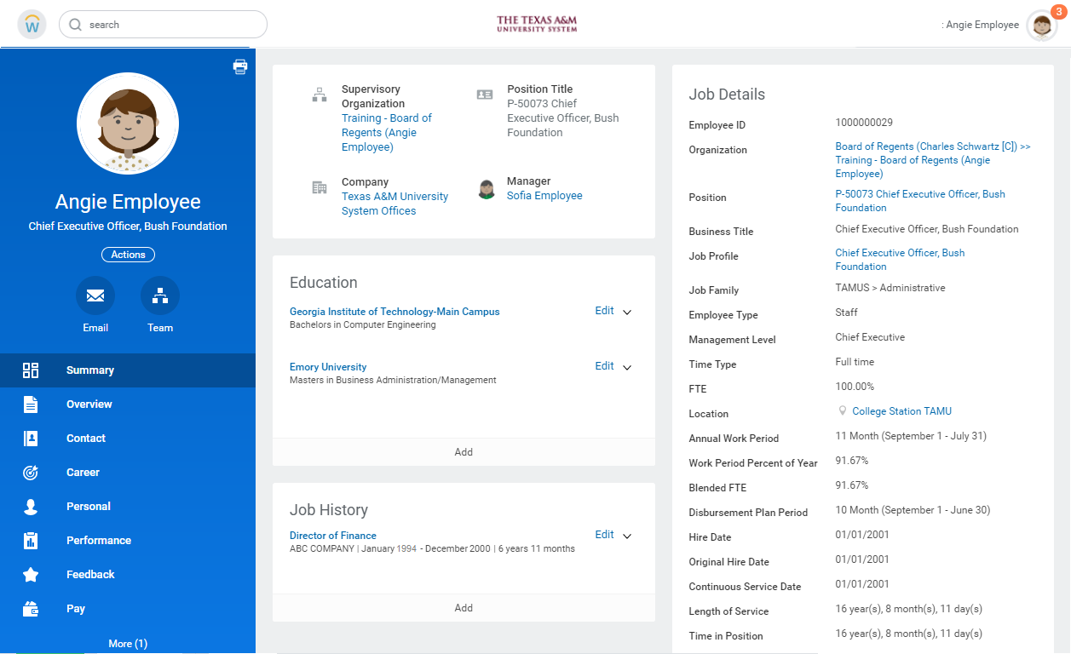

# Employee Self Service Activities (Faculty, Staff and Student Workers)

This section provides an overview of various self-service actions available to employees. Follow the instructions to explore self-service features.

**Note:** Changes you make in the Sandbox will NOT be carried over into Workday for Go Live. This activity is only for practice and will not update the actual production version.

## Activity 1: Update Personal Information

On the Workday Home page:

1. Click the Personal Information worklet



1. In the Change section, click Personal Information

Personal information page with change section displayed and personal information link highlighted for emphasis

1. In the **Gender** section, click the **Edit** icon null to add or edit information about your gender
2. In the **Date of Birth** section, click the **Edit** icon null to add or edit information about your date of birth

**Note**: Changes in the date of birth require confirmation in the form of documentation to your HR staff

1. In the **Race/Ethnicity** section, click the **Edit** icon null to add or edit information about your race / ethnicity
2. In the **Citizenship Status** section, click the **Edit** icon null to add or edit information about your citizenship status
3. In the **Nationality** section, click the **Edit** icon null to add or edit information about your nationality
4. Enter any comments, as needed

comment field

1. Click **Submit**

The request will be routed to other individuals for additional steps.

To view the next steps, open the **Details and Process** section and then click the **Process** tab.

## Activity 2: Upload My Experience

On the Workday Home page:

1. Click the **My Account** icon on the top right (cloud icon or profile picture) and click **View Profile** on the drop-down menu

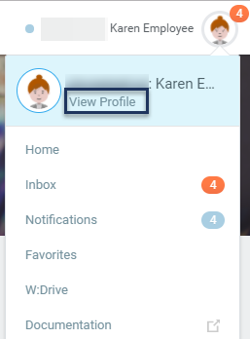

The **Worker Profile** page displays

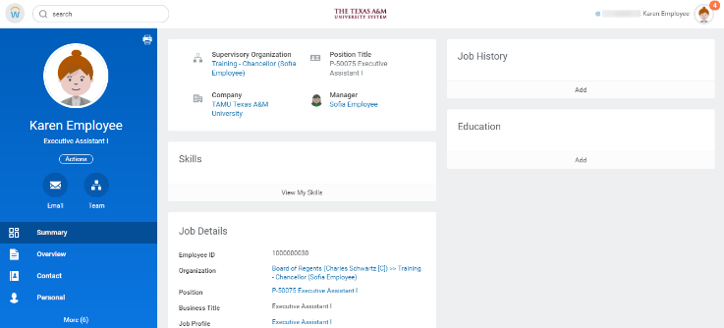

1. Click **Career** from various sections of the Worker Profile on the left

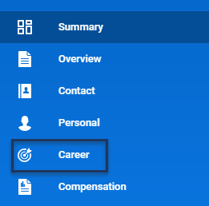

1. On the Career page, on the Education tab, click Upload My Experience

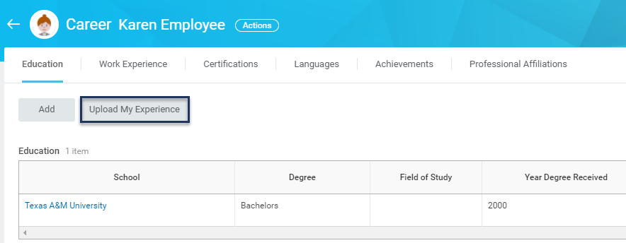

**Note:** Edit or remove the existing education details by clicking **Edit** or **Remove**, respectively

1. On the **Upload My Experience**, you can upload your resume by selecting or dragging the file

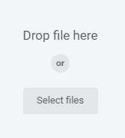

1. Click **Submit**

This completes the Upload My Experience process

## Activity 3: Enter Time

This section outlines the process for employees to enter time.

**Important Information:**

* Time can be entered by **hourly employees** and **salaried employees tracking time on projects**. Hours entered by salaried employees are for record keeping only and do not feed to payroll
* Time entry policies vary by member. Please note that some members will enter time with the number of hours worked and others will enter time with the exact times worked

On the Workday Home page:

1. Click the **Time** worklet



1. Click This Week

The **Time Calendar** will display

Note:

* The number of hours already entered for the week will also display
* Alternatively, you can click **Last Week** or **Select Week**

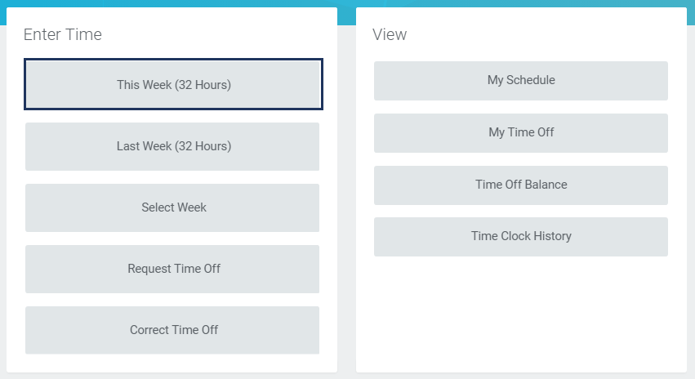

1. Click under the date where you want to add hours

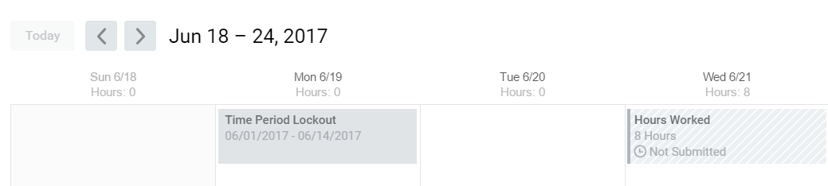

A blue **Enter Time** box should appear, and then a pop-up will display

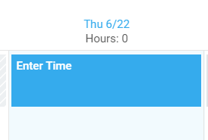

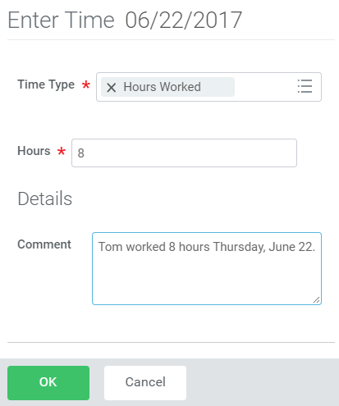

1. Complete the following fields:

* **Time Type (either Project, Time Entry Code or Absence Code)**
* **Hours**
* **Comment**

**Note:** Some members will enter exact times rather than the number of hours for each day

1. Click **OK**

The time entered displays on the **Time Calendar**

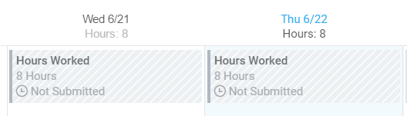

**Note:** Alternatively, click **Enter Time** at the bottom of the page to view a drop-down list of other options. From here, you can select from the following options pertaining to time entry:

* Auto-fill from Prior Week
* Auto-fill from Schedule
* Clear
* Enter Time
* Review Time
* Review Time by Week

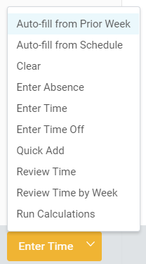

**Note:** Auto-fill from Prior Week and Auto-fill from Schedule will also add time to the calendar

1. Once all time has been correctly entered on the calendar, click **Submit** to continue
2. On the **Submit Time** summary page, review the time entered on the previous page

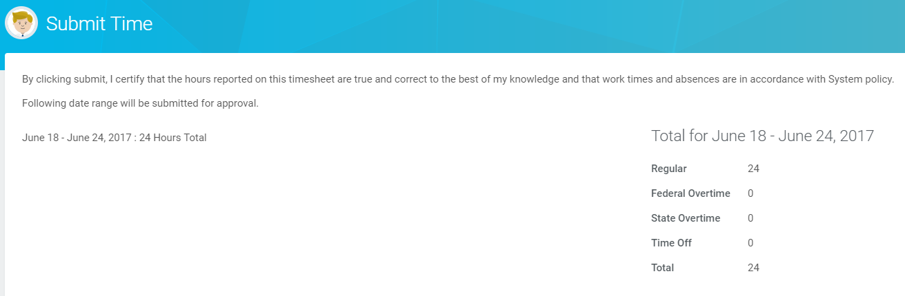

1. Click **Submit**
2. Enter any comments, as needed
3. Click **Submit**

The request will be routed to other individuals for additional steps. To view the next steps, open the **Details and Process** section and then click the **Process** tab.

This completes the **Enter Time** process.

## Activity 4: Request Time Off

This section outlines the process for an employee to Request Time Off.

On the Workday Home page:

1. Click the **Time Off** worklet



1. In the **Request** section, Click **Time Off**

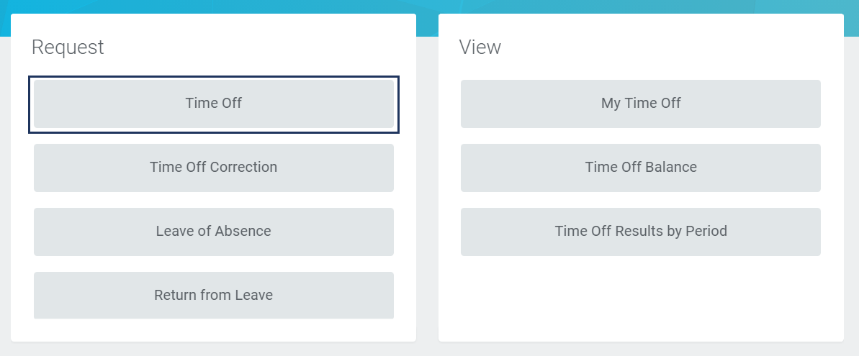

The **Time Off Calendar** page will display

1. Select a date in the left column to see your **Time Off Balance** as of that date
2. Click and drag over the dates on the calendar for the date range you will be taking time off. Alternatively, click on each individual date you will be off if they are not sequential

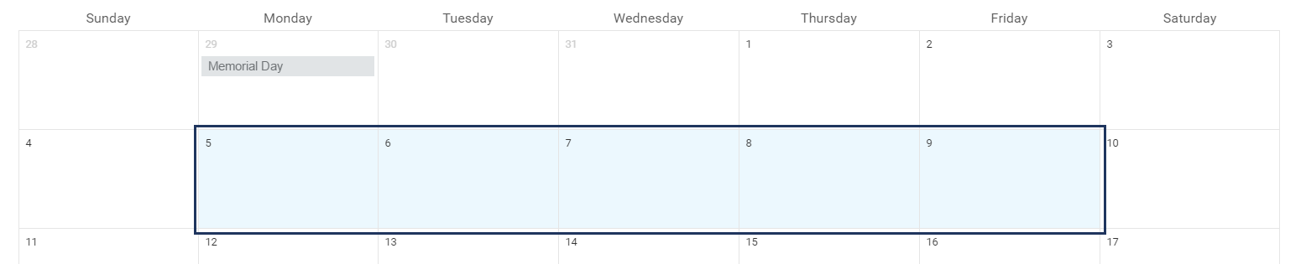

1. At the bottom of the screen, a green button will say how many days were selected. Click the **Request Time Off** button

Green button to click that indicates the number of days that have been requested with the confirmation phrase Request Time Off

1. In the pop-up window that displays, complete the following fields:
   1. Time Off Type
   2. Daily Quantity
   3. **Reason** (Required for certain Time Off Types)
2. Enter any comments,as needed

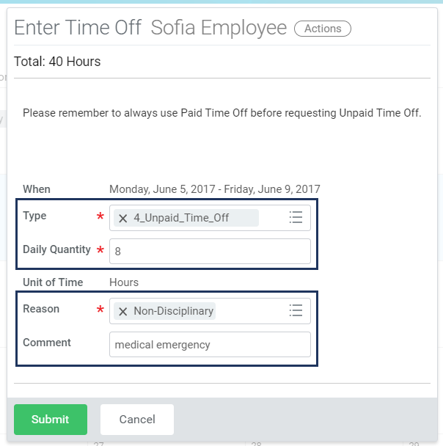

**Note:** Only **Types** that you are eligible for will appear. **Daily Quantity** enables you to enter in a partial day off if necessary. **Reason** options will appear based on the **Type** selected.

1. Click **Submit**
2. Your Manager will receive an inbox task to approve your **Time Off Request.** The manager can view the details of the request and **View Balance**. The manager then clicks **Approve** on the inbox task

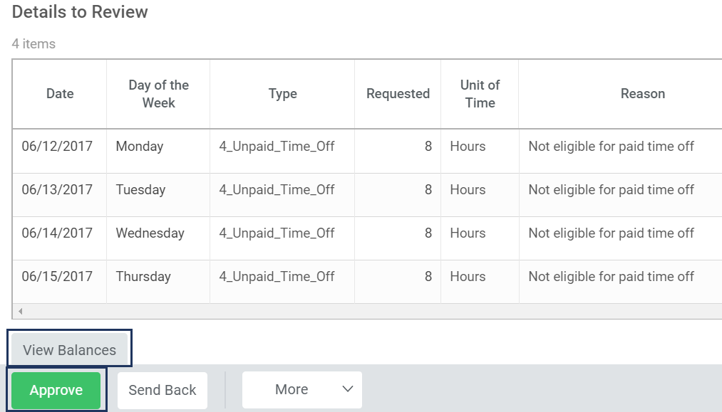

**Request Time Off** is now complete. The time off will appear on your **Time Off Calendar** and be visible to you, your Manager and the Absence Partner

This completes the **Request Time Off** process.

# Appendix 1: Workday – Terminology

|  |  |
| --- | --- |
| **Term** | **Description** |
| **Benefit event** | An event that gives you the opportunity to change your benefit elections. These include staffing events (such as getting hired) and life events (such as getting married or having a child) |
| **Business object** | A set of related fields. Instances of a business object include rows in a table or a spreadsheet, with each instance representing a unique occurrence of that type of object, such as an organization or a worker. A business object can have no instances, one instance or many instances. Workday automatically links related business objects together. For example, supervisory organization details are linked to a supervisory organization; the supervisory organization is linked to positions; positions are linked to employees; and so on |
| **Business process** | A task that you can initiate, act upon and complete to accomplish a desired business objective. Business processes are created using a combination of actions, approvals, approval chains, To Dos and/or checklists. An action can be a single task or sub-process, which is also a combination of actions, To Dos and/or checklists. Within the process, conditions can be defined that will identify whether a step will be initiated. Notifications can also be created to let a Workday user know that a step has begun or been completed or that a particular review response was selected. Examples of business processes include Hire, Change Job, Request Compensation Change, Terminate Employee etc. |
| **Drill-down** | A feature to view more data in a matrix report. When you click a drillable element (such as a drillable field in the table view or a column, line or pie segment in the chart view), a context menu appears that enables you to select a new View By field. If the **Enable Drilldown to Detail Data** check box is selected on the **Advanced** tab of the report definition, you can also select details associated with the selected report element |
| **Event** | A transaction that occurs within your organization, such as hiring or terminating a worker |
| **Field** | An area that contains data related to a particular primary or related business object |
| **Filter** | A clickable icon used to narrow down data. Clicking this icon will create a row on your report where you filter data to display from one or more columns |
| **Full Time Equivalent (FTE) %** | The ratio of a worker's scheduled weekly hours to the weekly hours for the business site. If a worker works 20 hours a week and the business site weekly hours are 40, then the worker's FTE% is 50% |
| **Functional Area** | A group of tasks, reports and objects. For example, the HCM solution includes functional areas such as Benefits, Talent & Performance, Absence and Manager/Employee self-service. Each of Workday's solutions is grouped into distinct functional areas |
| **Headcount** | The number of workers in an organization |
| **I-9** | An employment eligibility verification. A document all workers must complete to verify their identity and employment authorization |
| **Life Event** | A benefit event that occurs in your personal life, such as getting married or having a child |
| **Open Enrollment Event** | A type of enrollment event that typically occurs once per year system wide. Unlike benefit event enrollment, which is triggered by a life event or job change, an open enrollment event applies to an entire employee and retiree population |
| **Org Chart** | A visual depiction of how an organization is structured. It outlines the roles and responsibilities of and relationships among individuals within an organization |
| **Performance Review Process** | The formal process to establish annual worker goals and conduct the performance evaluation process, which includes review and rating of goals, competencies and position responsibilities |
| **Pre-Hire** | A term used in Staffing to identify individuals (candidates) before employment and used in Recruiting to identify candidates who are in the Offer or Background Check stage |
| **Roles** | A group of people with specific responsibilities and permissions. When a business process runs, the role for each step includes all of the workers in that role in the business process target organization |
| **Staffing Event** | Any event that changes your position or job, such as a hire, a transfer or a promotion |
| **Supervisory Organization** | Workers grouped into a management hierarchy. Supervisory organizations are the primary organization type in Workday. All approvals and checklists are established for the supervisory organization hierarchy, with possible variations for particular organizations within that hierarchy |
| **Task** | An action you must take in a business process, unless you reassign or delegate the task. For example, notifications or inbox alerts are triggered by steps in a business process |
| **To-Dos** | Reminders to do something. They can be part of business processes and must be marked complete before the workflow will go to the next step |
| **W-4** | A withholding allowance certificate. This will inform an employer of how much income tax to withhold from your paycheck |
| **Worker** | A person who is either an employee hired by a company or a contingent worker contracted by a company |
| **Worker Profile** | A continuously updated page that provides a quick view of an employee’s experience, skills, education and projects |
| **Worklet** | A compact report displayed as an app on your Home page, providing easy access to tasks and information you use on a regular basis. Examples of worklets include Pay, Time Off, Personal Information and Benefits |
| **Worktag** | Keywords that you can assign to transactions and supporting data to make their business purposes clear and establish common relationships through classification. You can find information more easily, filter searches down to focused results and analyze information in aggregated and summarized reporting by business dimension |

# Appendix 2: Common Worklets in Workday

|  |  |  |
| --- | --- | --- |
| **Name** | **Worklet** | **Description** |
| **Benefits** |  | A worklet linking you to common actions and views related to benefits, including change benefits, beneficiaries and dependents. You can use the worklet to view your benefit elections and current benefits cost |
| **Favorites** |  | A worklet containing favorite reports and tasks for easy access |
| **Inbox** |  | A worklet showing your action items, To Dos, and approvals; required for all users and cannot be removed from the Home page |
| **My Team** |  | A worklet linking you to common actions and views related to your team, including viewing your direct reports and their employment information (transfer, promotion or change of job). This worklet is being retired in 2018 |
| **My Team Management** |  | A worklet linking you to common actions and views related to your team, including viewing your direct reports and their recent activity. For example you can Transfer, Promote, or Change Job, Change Location, Add Job, Terminate and Place Worker on Leave here. Finally, you can view important information such as a team comparison, the Organization Directory, Headcount, Management Chain and Timeline |
| **Pay** |  | A worklet linking you to common actions and views related to your pay, including accessing withholding elections and payment elections and viewing payslips, total compensation, bonus and one-time payment history, tax documents and allowance plans |
| **Personal Information** |  | A worklet linking you to common actions and views related to your personal information, including changing your contact and personal information (such as your addresses, e-mail and phone number), emergency contacts, photo, legal name, preferred name and government IDs; required for all users and cannot be removed from the Home page |
| **Safety** |  | A worklet enabling employees, managers and safety partners to report safety incidents |
| **Time** |  | A worklet linking you to common actions and views related to your time, including entering your time and viewing your time-off balance |
| **Time Off** |  | A worklet linking you to common actions and views related to time off, including viewing your time-off correction, leave of absence, time off and time-off balance |