Change Benefits (Beneficiary Change Only)

Overview
This job aid outlines the process for an Employee to add or edit a new beneficiary and make changes to coverage eligible for change outside of a life event or open enrollment
Prerequisites: N/A
Important Information:
  - The beneficiary must be added as a beneficiary before they can be attached to a plan using the Beneficiary Change Only event type in the Change Benefits process
  - Changes to medical benefits can only be made during open enrollment or if there has been a qualified life event

Steps

Add Beneficiary
From the Workday Home page:
- Click the Benefits worklet
- Click the Beneficiaries button under Change
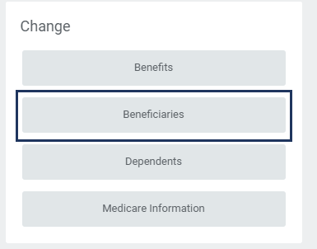
- The Beneficiaries page is displayed. Click Add to add a new beneficiary

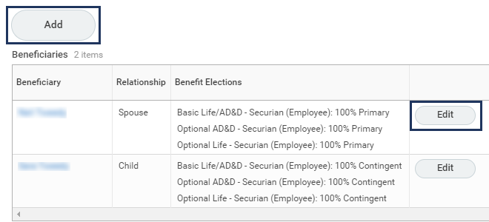
IMPORTANT: You must first add a beneficiary prior to adding them to any benefits so that they become an option in the drop down menu when you go to change benefits
Note: You can also edit information on a currently listed beneficiary on this page as shown here
- On the Add My Beneficiary page, select one of the following options:
- Create a New Beneficiary
- Create a New Trust as Beneficiary
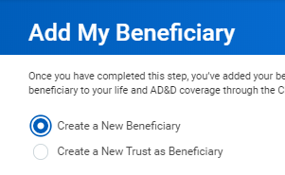
- Click OK
- Complete or edit the following required fields:
- Country
- First Name
- Last Name
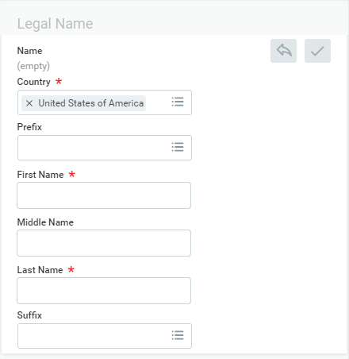
- Select the appropriate Relationship to the Employee (Child, Spouse, Parent, Sibling, etc.)
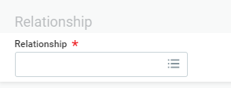
- Enter the Date of Birth and Gender for the beneficiary
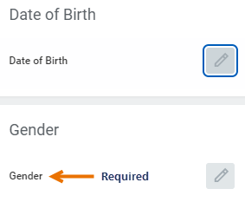
Note: Gender is a required field
- Enter any Primary or Additional Address, Phone Numbers or Emails for the beneficiary in the Contact Information section by clicking Add
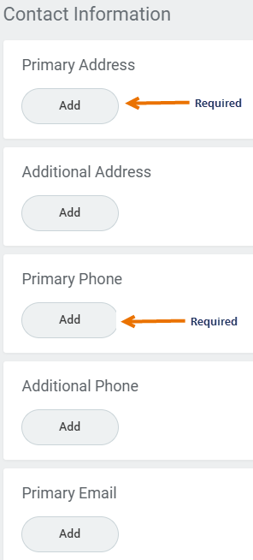
Note: Primary Address and Primary Phone Number are required fields
Click Submit. You will receive a To Do providing instructions on how to add this Beneficiary to your Benefits (see the next section for details)
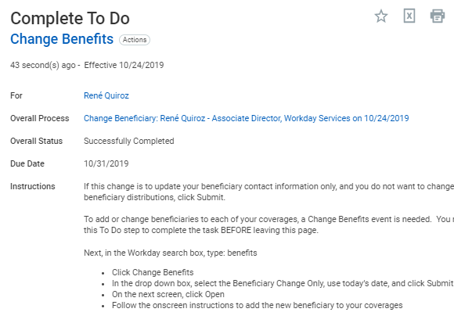
Note: If you only made an edit to a beneficiary’s data and do not need to make changes to the benefits elections attached to the individual and then Submit

Up Next
If you need to add this beneficiary to coverage, the next step is to attach the beneficiary to your life and/or AD&D coverage through the Change Benefits process. This is critical to the completion of the Change Beneficiary process

Change Benefits
From where you left off in adding the new beneficiary, from the To Do in your inbox or from the Workday Home page you can begin this process. This section guides you from the Workday Home page:
- Click the Benefits worklet
- Click Benefits under the Change column
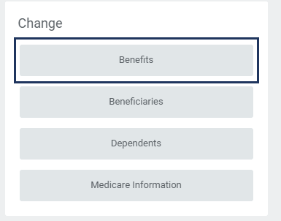
- Complete the following:
  - Benefit Event Type. Select Beneficiary Change Only from the drop-down listing
  - Benefit Event Date. Enter today’s date
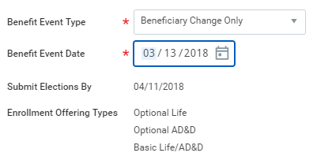
Note: The Submit Elections By and Enrollment Offering Types will auto-populate based on what is selected previously
- Click Submit
- You will see the following message:
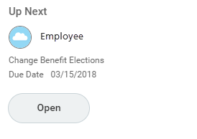
- Click Open

Tobacco Use
- You will now have an opportunity to make updates to Tobacco Use for you and your spouse
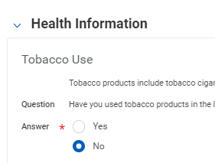
- Click Continue

Insurance Elections
This section is not available for updates unless you initiate the Change Benefits business process for a Life Event
- Click Continue

Beneficiary Designations
- Here you can add beneficiaries to your coverages eligible for changing outside of a life event or open enrollment
Locate the plan for which you want to make a change and under the Beneficiary column you will Add, Delete or Edit a chosen beneficiary from the plan. See below
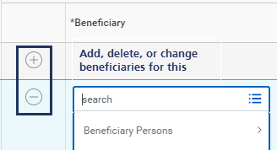
- Make sure you designate Primary or Contingent Percentages
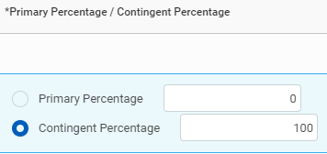
- Click Continue
- Select the I Agree checkbox after reviewing the elections
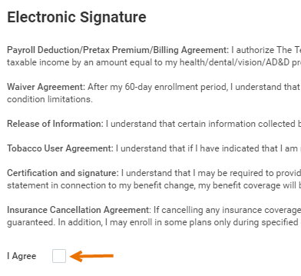
- Click Submit
This completes the Change Benefits (Beneficiary Change Only) process

